Screens

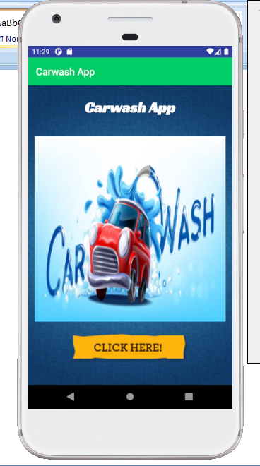

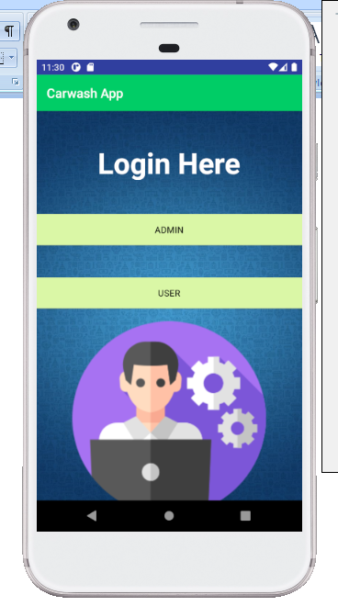

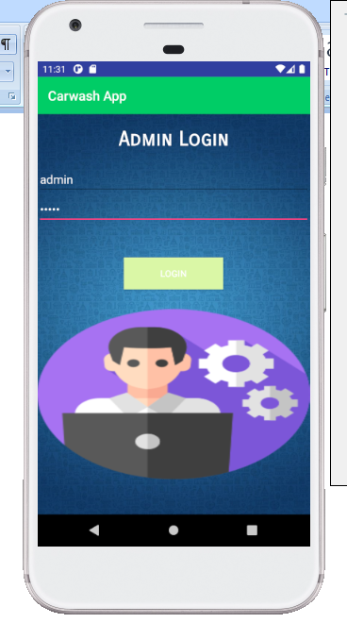

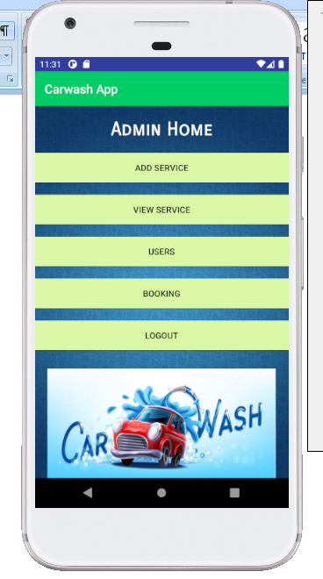

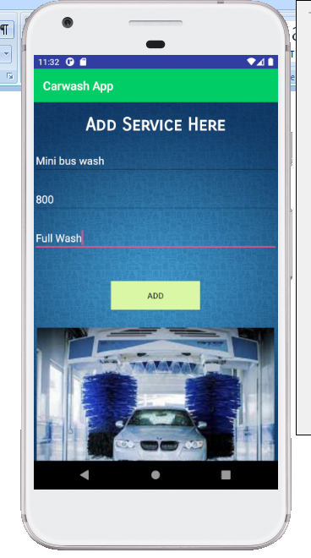

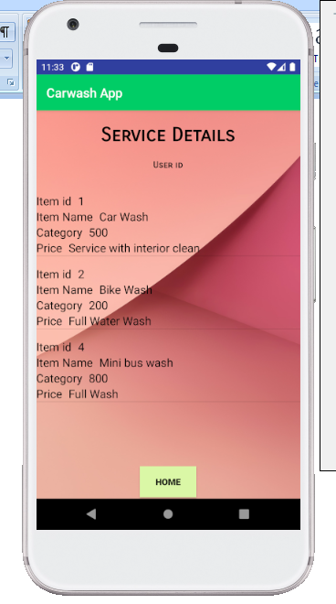

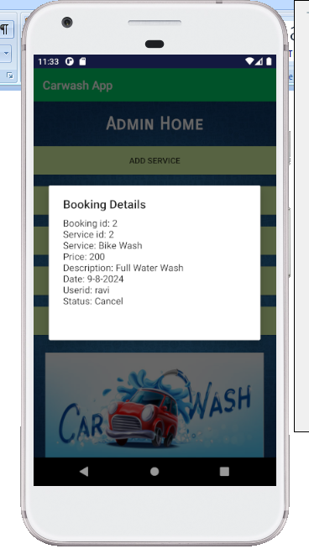

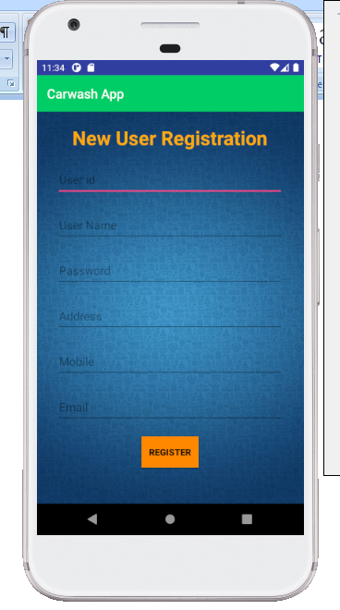

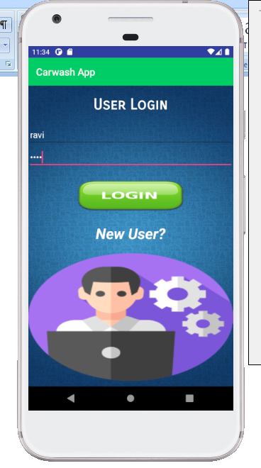

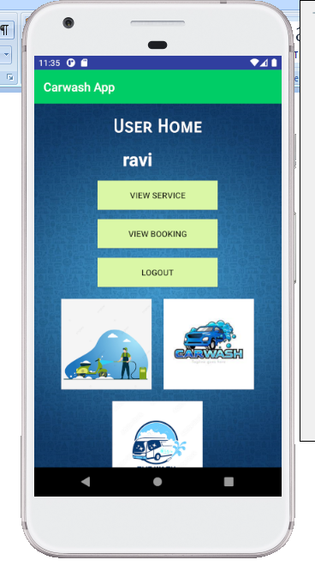

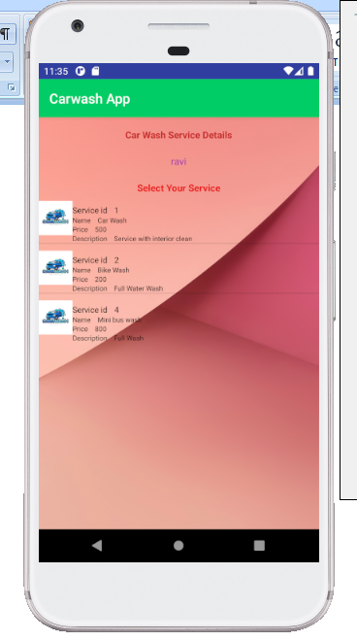

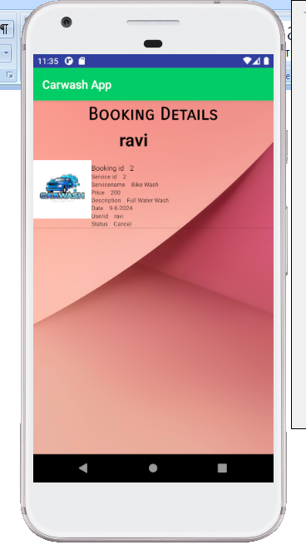

Coding

**package** com.example.dell_pc.libraryproject;  
  
**import** android.content.Intent;  
**import** android.os.StrictMode;  
**import** android.support.v7.app.AppCompatActivity;  
**import** android.os.Bundle;  
**import** android.view.View;  
**import** android.widget.EditText;  
**import** android.widget.Toast;  
  
**public class** Userreg **extends** AppCompatActivity {  
 EditText **e1**,**e2**,**e3**,**e4**,**e5**,**e6**;  
 @Override  
 **protected void** onCreate(Bundle savedInstanceState) {  
 **super**.onCreate(savedInstanceState);  
 setContentView(R.layout.***activity_userreg***);  
  
 **e1** = (EditText) findViewById(R.id.***editText5***);  
 **e2** = (EditText) findViewById(R.id.***editText6***);  
 **e3** = (EditText) findViewById(R.id.***editText9***);  
 **e4** = (EditText) findViewById(R.id.***editText10***);  
 **e5** = (EditText) findViewById(R.id.***editText12***);  
 **e6** = (EditText) findViewById(R.id.***editText13***);  
 }  
  
 **public void** sregi(View arg)  
 {  
 **if** (android.os.Build.VERSION.***SDK_INT*** >= 9) {  
 StrictMode.ThreadPolicy policy = **new** StrictMode.ThreadPolicy.Builder().permitAll().build();  
 StrictMode.*setThreadPolicy*(policy);  
 }  
  
 **try** {  
  
 Boolean loginStatus = WebService.*Newusers*(**e1**.getText().toString(),**e2**.getText().toString(),**e3**.getText().toString(),**e4**.getText().toString(),**e5**.getText().toString(),**e6**.getText().toString(),**"Newuser"**);  
  
 Toast.*makeText*(Userreg.**this**, **"Register Successfully"**, Toast.***LENGTH_LONG***).show();  
 Intent i = **new** Intent(Userreg.**this**, userlogin.**class**);  
 startActivity(i);  
 }  
  
 **catch** (Exception e)  
 {  
 Toast.*makeText*(Userreg.**this**, **"Exception"**, Toast.***LENGTH_LONG***).show();  
  
 }  
  
 }  
  
}

**package** com.example.dell_pc.libraryproject;  
  
**import** android.content.Context;  
**import** android.content.Intent;  
**import** android.os.StrictMode;  
**import** android.support.v7.app.AppCompatActivity;  
**import** android.os.Bundle;  
**import** android.view.LayoutInflater;  
**import** android.view.View;  
**import** android.view.ViewGroup;  
**import** android.widget.AdapterView;  
**import** android.widget.ArrayAdapter;  
**import** android.widget.BaseAdapter;  
**import** android.widget.EditText;  
**import** android.widget.GridView;  
**import** android.widget.ImageView;  
**import** android.widget.ListView;  
**import** android.widget.Spinner;  
**import** android.widget.TextView;  
**import** android.widget.AdapterView.OnItemClickListener;  
**import** android.widget.Toast;  
  
**import** android.app.DatePickerDialog;  
**import** android.widget.Button;  
**import** android.widget.DatePicker;  
**import** android.widget.TextView;  
**import** java.util.Calendar;  
  
  
**public class** Booking **extends** AppCompatActivity {  
 EditText **e1**,**e2**,**e3**,**e4**;  
 TextView **t1**,**t2**;  
 String **usern**,**serid**;  
 **public** GridView **data**;  
  
  
  
  
 TextView **tv**;  
 *// String usern;* **public** ListView **lv**;  
 **public** String **login**;  
 **public int rowcount**=0;  
  
 **private** Button **pickDateBtn**;  
 **private** TextView **selectedDateTV**;  
 @Override  
 **protected void** onCreate(Bundle savedInstanceState) {  
 **super**.onCreate(savedInstanceState);  
 setContentView(R.layout.***activity_booking***);  
 **try** {  
  
 Intent ii = getIntent();  
 **t1** = (TextView) findViewById(R.id.***textView27***);  
 **t2** = (TextView) findViewById(R.id.***textView28***);  
  
 **e1** = (EditText) findViewById(R.id.***editText16***);  
 **e2** = (EditText) findViewById(R.id.***editText17***);  
 **e3** = (EditText) findViewById(R.id.***editText18***);  
 **e4** = (EditText) findViewById(R.id.***editText19***);  
  
  
  
 **usern** = ii.getStringExtra(**"userid"**);  
 **serid** = ii.getStringExtra(**"Servid"**);  
 **t1**.setText(**usern**);  
 **t2**.setText(**serid**);  
  
  
 *//* **if** (android.os.Build.VERSION.***SDK_INT*** >= 9) {  
 StrictMode.ThreadPolicy policy = **new** StrictMode.ThreadPolicy.Builder().permitAll().build();  
 StrictMode.*setThreadPolicy*(policy);  
 }  
  
  
 *//* **login**=WebService.*Viewserv*(**t2**.getText().toString(),**"Viewser"**);  
 String[] str=**login**.split(**","**);  
  
 **if**(str[0].equals(**"ok"**))  
 {  
 String sid=str[1].toString();  
 String sname=str[2].toString();  
 String price=str[3].toString();  
 String des=str[4].toString();  
 **e1**.setText(sid);  
 **e2**.setText(sname);  
 **e3**.setText(price);  
 **e4**.setText(des);  
  
 }  
 **else** {  
 Toast.*makeText*(getApplication(),**"No Data"**,Toast.***LENGTH_SHORT***).show();  
  
 }  
  
 *//* }  
  
 **catch** (Exception e)  
 {  
 Toast.*makeText*(getApplication(),**"No Data"**,Toast.***LENGTH_SHORT***).show();  
  
 }  
  
  
 *//  
  
  
 // on below line we are initializing our variables.* **pickDateBtn** = findViewById(R.id.***idBtnPickDate***);  
 **selectedDateTV** = findViewById(R.id.***idTVSelectedDate***);  
  
*// on below line we are adding click listener for our pick date button* **pickDateBtn**.setOnClickListener(**new** View.OnClickListener() {  
 @Override  
 **public void** onClick(View v) {  
 *// on below line we are getting  
 // the instance of our calendar.* **final** Calendar c = Calendar.*getInstance*();  
  
 *// on below line we are getting  
 // our day, month and year.* **int** year = c.get(Calendar.***YEAR***);  
 **int** month = c.get(Calendar.***MONTH***);  
 **int** day = c.get(Calendar.***DAY_OF_MONTH***);  
  
 *// on below line we are creating a variable for date picker dialog.* DatePickerDialog datePickerDialog = **new** DatePickerDialog(  
 *// on below line we are passing context.* Booking.**this**,  
 **new** DatePickerDialog.OnDateSetListener() {  
 @Override  
 **public void** onDateSet(DatePicker view, **int** year,  
 **int** monthOfYear, **int** dayOfMonth) {  
 *// on below line we are setting date to our text view.* **selectedDateTV**.setText(dayOfMonth + **"-"** + (monthOfYear + 1) + **"-"** + year);  
  
 }  
 },  
 *// on below line we are passing year,  
 // month and day for selected date in our date picker.* year, month, day);  
 *// at last we are calling show to  
 // display our date picker dialog.* datePickerDialog.show();  
 }  
 });  
  
 *//* }  
  
  
 **public void** goh(View arg)  
 {  
 Intent i = **new** Intent(**this**, Userhome.**class**);  
 i.putExtra(**"userid"**,**t1**.getText().toString());  
 startActivity(i);  
 }  
  
 **public void** Bookh(View arg)  
 {  
 **if** (android.os.Build.VERSION.***SDK_INT*** >= 9) {  
 StrictMode.ThreadPolicy policy = **new** StrictMode.ThreadPolicy.Builder().permitAll().build();  
 StrictMode.*setThreadPolicy*(policy);  
 }  
  
 **try** {  
  
 Boolean loginStatus = WebService.*Bookinghere*(**e1**.getText().toString(),**e2**.getText().toString(),**e3**.getText().toString(),**e4**.getText().toString(),**selectedDateTV**.getText().toString(),**t1**.getText().toString(), **"Booking"**);  
  
 Toast.*makeText*(**this**, **"Added Successfully"**, Toast.***LENGTH_LONG***).show();  
  
 }  
  
 **catch** (Exception e)  
 {  
 Toast.*makeText*(**this**, **"Exception"**, Toast.***LENGTH_LONG***).show();  
  
 }  
  
 }  
  
  
  
}